SALT NIR Integral Field Spectrograph
Description and Performance Predictions
June 2022
Author: Marsha Wolf (PI)

Introduction
Washburn Astronomical Laboratories of the University of Wisconsin-Madison Astronomy Department has developed a near infrared integral field spectrograph for the 11-meter Southern African Large Telescope (SALT). The spectrograph name has defaulted to “NIR” to distinguish it from the original RSS-NIR that would have mounted to RSS-VIS at the prime focus. NIR is now a standalone integral field spectrograph fed by a fiber bundle that resides inside a cold enclosure in the spectrometer room, next to the HRS enclosure (Figure 1). The instrument is now called NIRWALS (Near Infrared Washburn Astronomical Laboratories Spectrograph).
This instrument is the first to extend SALT’s capabilities into the near infrared, providing medium resolution spectroscopy at R = 2000-5000 over the wavelength range of 800 to 1700 nm. Its integral field unit (IFU) is an elongated hexagonal bundle of 212 fibers, each of which subtends 1.3 arcsec on the sky, approximately matching the median site seeing. The IFU has on-sky dimensions of 29 x 18 arcsec, ideally suited for resolving nearby galaxies. A separate 38-fiber bundle simultaneously samples the sky. It can be adjusted to distances ranging from 48.6 to 159.2 arcsec from the object IFU with a gimbaled jaw in the Fiber Instrument Feed (FIF) that maintains telecentricity and common field angles for the object and sky bundles. Sky fibers are interleaved with object fibers along the 8-arcmin long spectrograph slit for optimizing sky subtraction. The spectrograph is cooled to -40 °C in an enclosure beneath the telescope, with the cryogenic dewar inside this enclosure operating at 120 K via a separate closed cycle cooler. The spectrograph uses volume phase holographic gratings with an articulated camera, similar to RSS, for setup versatility. The spectrograph has been fully tested in the laboratory at the University of Wisconsin and is currently being installed and commissioned on SALT.
Instrument parameters are summarized in Table 1.

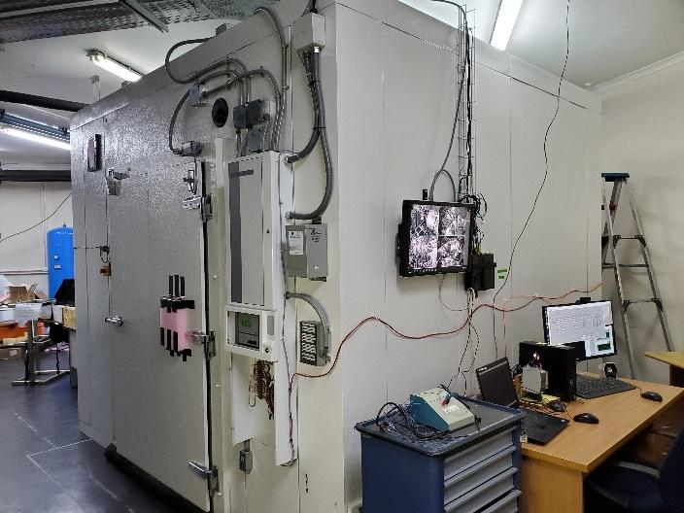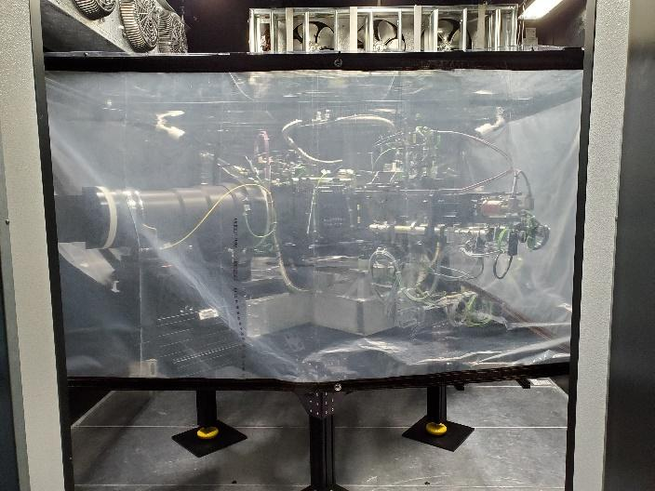
Figure 1. The NIR enclosure in the SALT Spectrometer Room (left) and the instrument inside (right). The fiber cable will enter the enclosure through the rectangular hole (currently filled with pink foam) in the upper left corner above the door. The plastic shroud around the spectrograph is to shield optical components from direct air currents from the cooling system.

Table 1. Summary of instrument parameters.
Wavelength coverage | 800 – 1700 nm
Spectral resolution (R) | 2000 - 5000
Peak predicted throughput | 0.40
Number of fibers in IFU | 212
IFU field of view on-sky | 18 x 29 arcsec
Fiber size on-sky | 1.33 arcsec
Number of fibers in sky bundle | 36
Sky bundle field of view on-sky | 4 x 29 arcsec
Adjustable sky bundle distance from IFU | 48.6 - 159.2 arcsec

Capability Description

Spectral Properties
The spectrograph was designed with a suite of 4 diffraction gratings to cover the 800 – 1700 nm spectral range at all spectral resolutions. Predicted diffraction efficiency for the grating suite is shown in Figure 2 on the left. Currently, only the 950 l/mm grating is available (more gratings can be added with additional funding). Its performance is shown on the right of Figure 2. Six grating angles are required to cover the entire spectral, excluding the strong atmospheric absorption between J and H bands.
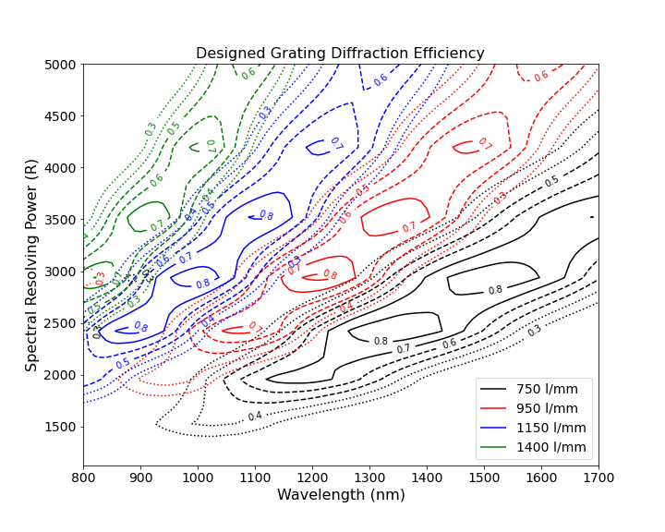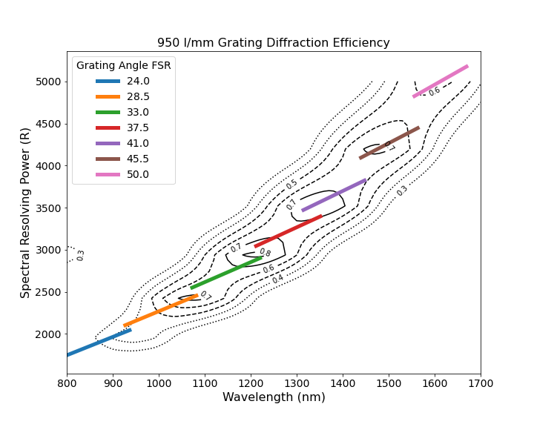
Figure 2. Predicted diffraction efficiency for the designed grating suite (left) as a function of wavelength and spectral resolution. The 950 l/mm grating performance is repeated on the right with the grating free spectral range (FSR) shown for a range of grating angles spanning the observable spectral range.

Instrument Throughput
The top of the atmosphere total throughput is estimated in Figure 3. This includes the latest telescope throughput measured using SALTICAM on 7/4/2022 (it is down by ~10% due to a problem with the mirror coating plant). The peak is 25% at 1200 nm. The throughput falloff at both ends of the spectral range is largely dominated by the grating efficiency. This would improve with more gratings.
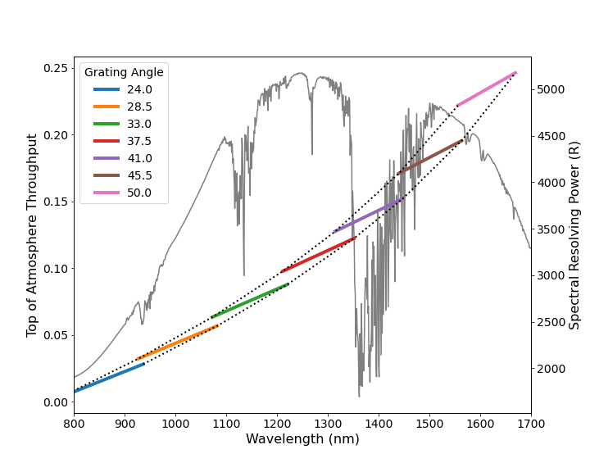
Figure 3. Top of the atmosphere predicted throughput of the instrument and telescope (left axis). Grating coverage for a set of angles spanning the entire range are shown. The 41-degree angle falls within strong atmospheric absorption, so should be avoided for typical setups. Excluding that region, the entire range can be covered with 6 instrument configurations. Spectral resolution as a function of wavelength (and grating angle) is shown on the right axis.

Predicted Performance
The night sky spectrum in the near infrared is filled with bright OH emission lines. A spectrum from Maunea Kea is shown in Figure 4. These emission lines add significant noise, limiting achievable S/N at their spectral locations. Estimated mean S/N per spectral resolution element for an extended source filling the fiber is given in Figure 5 as a function of object magnitude for an 1800 sec exposure. The mean limiting Vega magnitude for S/N = 5 in 1800 sec is 21, and 21.5 between sky emission lines. Figure 6 shows the predicted S/N spectra for each grating setting for a 22nd magnitude object.

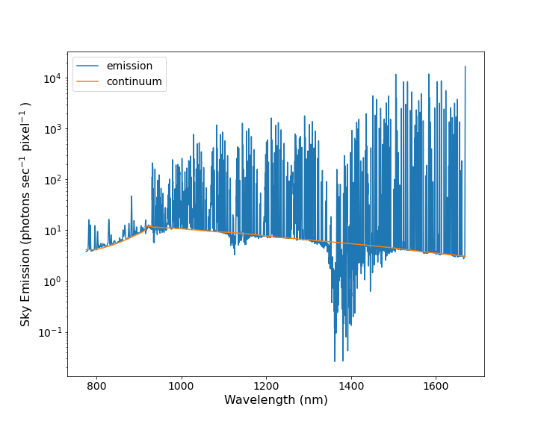
Figure 4. Sky emission spectrum from Maunea Kea. It has been smoothed to the NIR instrumental spectral resolution.
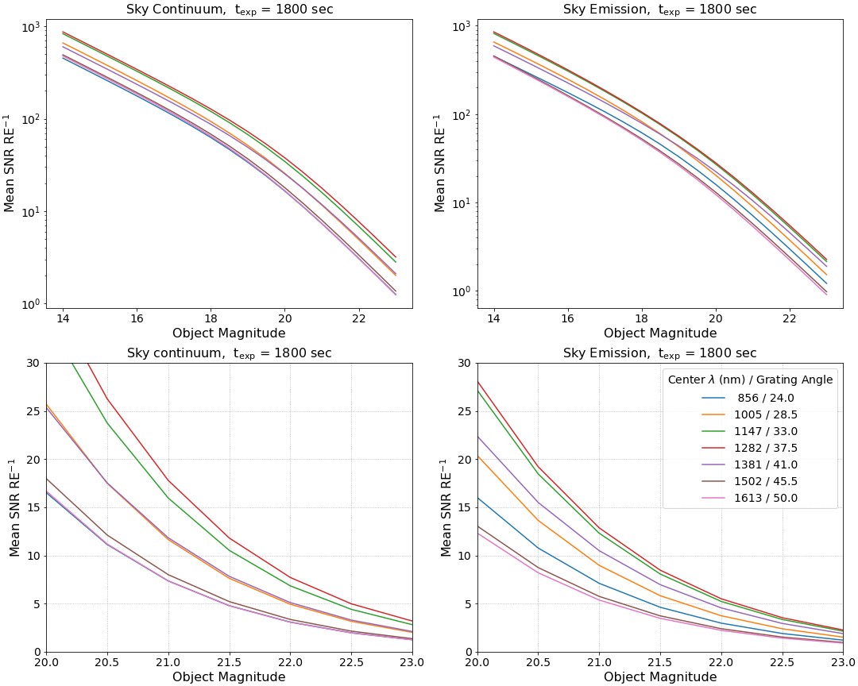
Figure 5. Estimated mean S/N per resolution element for an extended source filling the fiber, as a function of object magnitude, for an 1800 sec exposure. Plots on the left are for the sky continuum regions free of bright sky emission lines. Plots on the right are mean values over the entire grating FSR, including sky emission line regions.

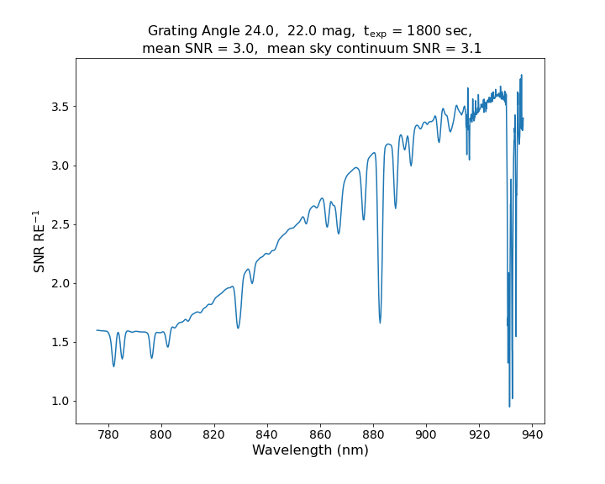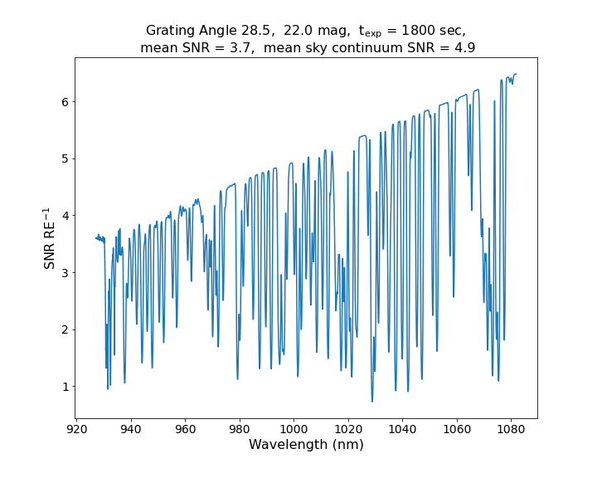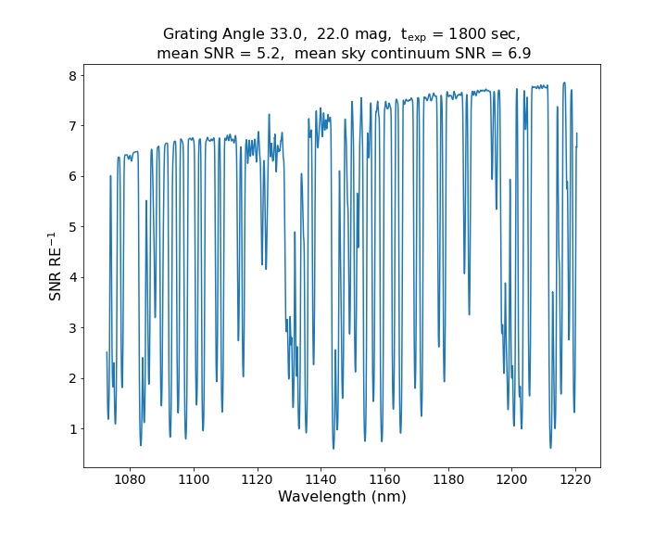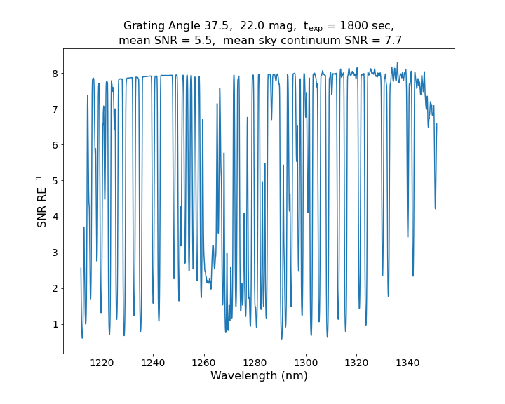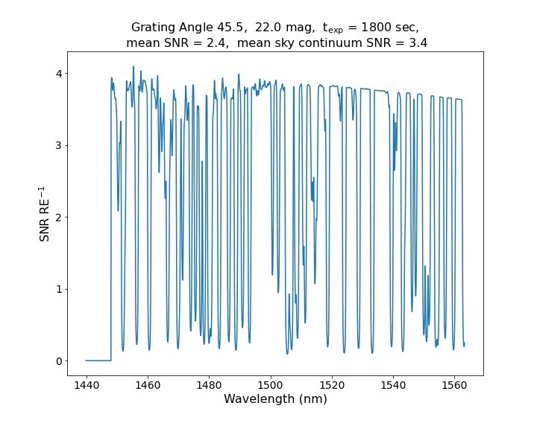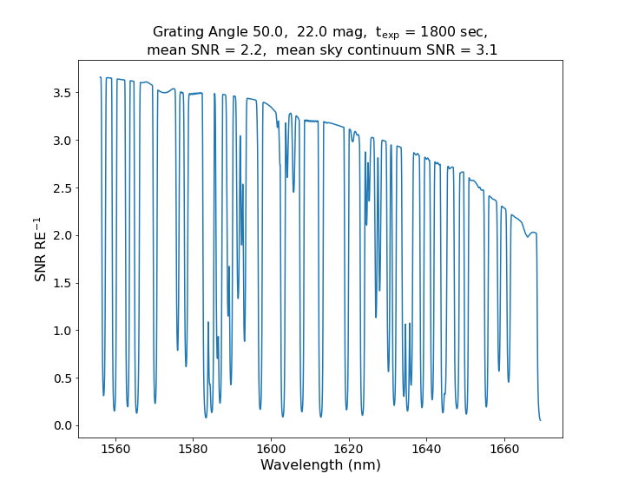
Figure 6. Estimated S/N per resolution element in each of the 6 grating settings (grating angle is listed in the title of each panel) for a 22nd magnitude extended object. The panel titles give the mean S/N for both the full spectral range and for just the emission line-free continuum regions.

Integral Field Unit
The integral field unit contains 212 object fibers. Its extent on the sky is 29 x 18 arcsec. A separate sky bundle contains 36 fibers (2 of 38 fibers were broken during construction), with an extent on-sky of 4 x 29 arcsec. The layouts are shown on the left of Figure 7. These fiber ferrules are mounted in the SALT fiber instrument feed (FIF), which also holds fibers that feed the HRS (Figure 7, right). The object IFU is mounted in the top jaw and the sky bundle in the bottom jaw. The distance between the two is adjusted by moving the jaws apart. This separation distance range is 48.6 to 159.2 arcsec.
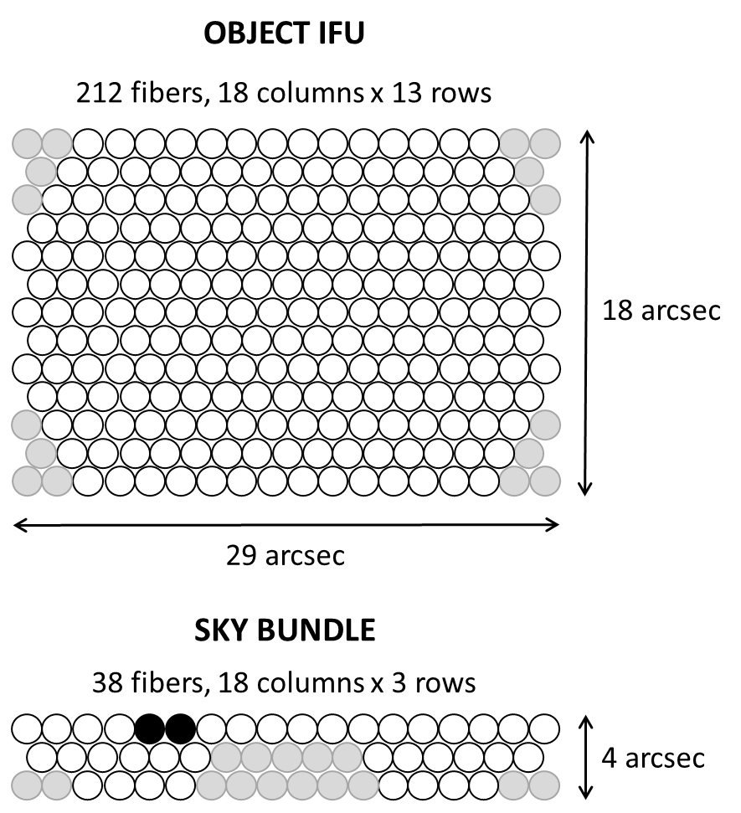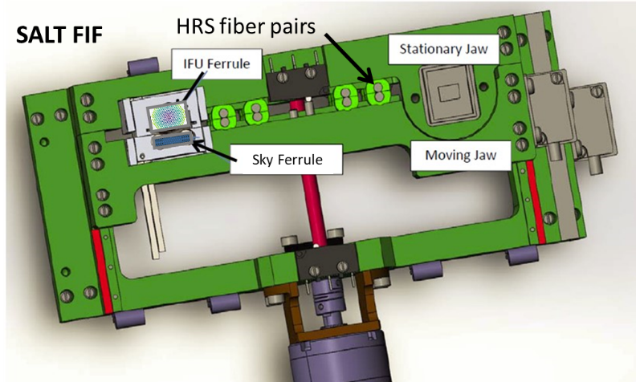
Figure 7. Layout of the object IFU and the sky bundle (left). Gray fibers are unused and black fibers are broken. Mounting of the ferrules in the SALT fiber instrument feed (right). The FIF jaws separate, providing an adjustable distance between the sky bundle and the object IFU.
The FIF will be used in bisector mode, placing the SALT optical field center between the IFU and sky bundle. As the FIF jaws separate, the mounting mechanism tilts each fiber bundle to the proper telecentric angle for that SALT field position (78 arcsec angle/arcsec field) for the center of the bundle. Because the IFU has a fixed size the fibers at the edges will have some telecentric angle offset relative to the center. This is shown in Figure 8. The arrangement of the sky bundle was designed to reproduce this distribution of telecentric angle errors. Object and sky fibers with similar telecentric errors are placed together along the slit.

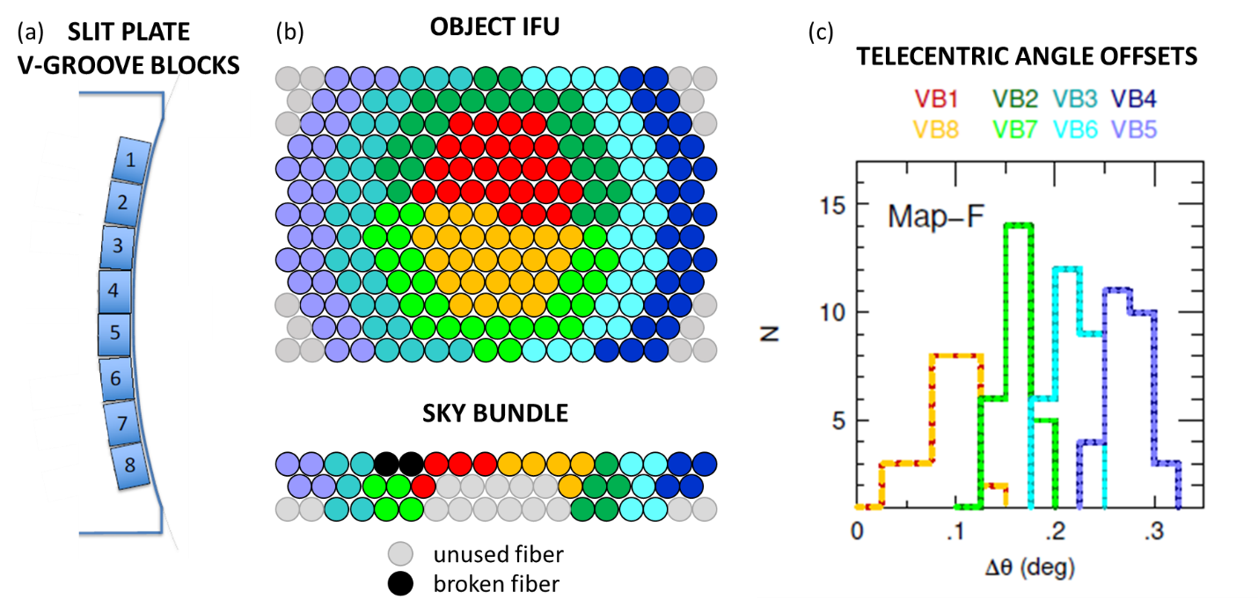
Figure 8. Fiber telecentricity considerations. (a) Fibers are arranged into a spectrograph entrance slit consisting of 8 V-groove blocks that range from 30 to 32 total fibers each (including 4-5 sky fibers). (b) Arrangement of object IFU and sky bundle fibers into slit blocks. The colors denote different V-groove blocks (VBx). (c) Telecentric angle offsets for fibers in the object IFU that map to labeled VB’s in the slit. The sky bundle arrangement was designed to sample this distribution of offsets. Sky fibers and object fibers with similar telecentric angle errors are placed together along the slit.

Detector System
The NIR detector is a Hawaii-2RG, 2048 x 2048 array with 18-micron pixels. Two modes are available for faint and bright objects. Relevant parameters for each are given in Table 2. Sampling modes include correlated double sampling (CDS), Fower sampling, and up-the-group-ramp (URG). Multiple sampling modes are explained in Figure 9. In Fowler sampling mode, reads at the beginning are averaged, reads at the end are averaged, and the two averages are subtracted. In URG mode, a slope is fit to the group reads up-the-ramp to reduce noise in the individual reads.

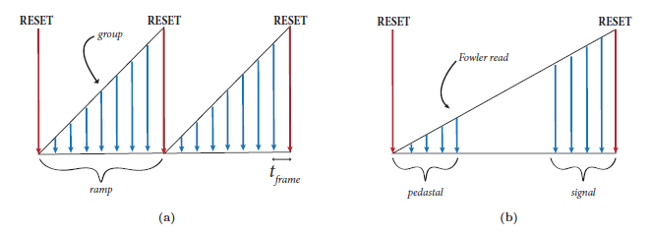
Figure 9. Detector sampling modes: up-the-ramp group sampling (left) and Fowler sampling (right). The vertical dimension represents accumulated signal in a pixel, and the horizontal dimension represents time, increasing to the right. Downward arrows represent times that the detector array is nondestructive read in groups up the ramp or in Fowler sampling at the beginning and end of a ramp.

Table 2. Detector parameters.
Readout channels | 32
Pixel sampling speed | 200 kHz
Frame readout time | 0.72275 sec
Measured | faint mode: 18 dB preamp gain | bright mode: 9 dB preamp gain
Conversion gain | 2.04 e-/DN | 5.49 e-/DN
CDS read noise (all pixels) | 24.6 +/- 6.2 e- | 40.1+/- 9.3 e-
Full well depth | 83,500 e- | 158,770 e-
Amplifier crosstalk | ~7 E-04
Estimated
Read noise Fowler-64(4) | 7.6 e- (19.8 e-) | 11.7 e- (30.3 e-)
Read noise URG-100(15) | 13.8 e- (22.7 e-) | 20.6 e- (33.7 e-)
NOTE: Fowler-64 has 64 reads at the beginning and end, URG-100 has 100 reads up the ramp during an exposure.

Observing Modes and Sky Subtraction
Envisioned observing modes include three main scenarios for sampling the sky.

Simultaneous Sky Bundle
These are observations of a target that fits within the object IFU field of view. The sky bundle is used to simultaneously sample the sky outside the object.

FIF Offsets
These offsets will be used when small dithers (<= 3 fiber diameters) are required to improve background subtraction in point source observations (Figure 10) and for “filling in the gaps between fibers” for mapping observations. They will also be used to map small extended targets (smaller than the IFU FOV). These will involve movement of the FIF stage. The movements will have a very high positional accuracy: <= 0.1 arcsec, the lowest overheads of the offset modes, but they will be limited to small offsets (< 5 arcsec) to avoid non-telecentricity effects.
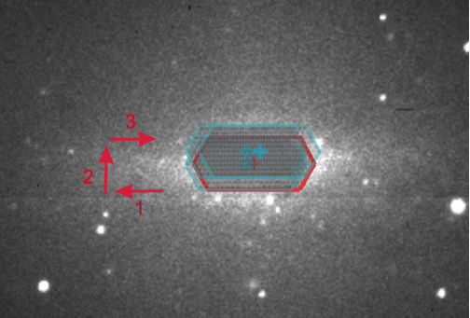
Figure 10. Illustration of NIR IFU science bundle positions and offsets for a small extended source that requires small dithers to better sample the field. The NIR IFU science bundle FOV (in the science and sky/offset positions) and central position overlays are shown in red, the offset directions are shown in cyan with an extended source in the background.

Tracker Offsets
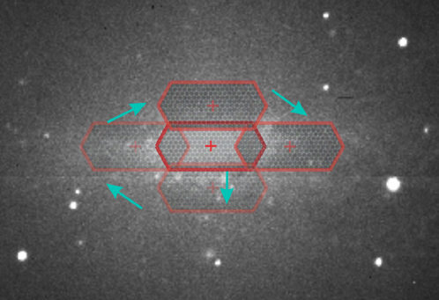
Figure 11. Illustration of NIR IFU science bundle positions and offsets for a large extended source that requires large dithers. The NIR IFU science bundle FOV (in the science and sky/offset positions) and central position overlays are shown in red, the offset directions are shown in cyan with an extended source in the background.
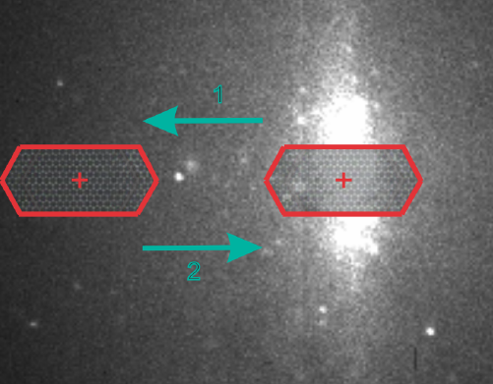
Figure 12. Illustration of NIR IFU science bundle positions and offsets for an extended source that requires large dithers. The NIR IFU science bundle FOV (in the science and sky/offset positions) and central position overlays are shown in red, the offset directions are shown in cyan with an extended source in the background.

Guided
These will consist of tracker movements with guidance maintained after the offset is made. The moves will have positional accuracy of <= 0.2 arcsec (dependent on the seeing) and limited to offsets of up to ~ 90 arcsec. The overheads will include the time required for the tracker movement and time waiting for the guidance to settle after the tracker movement. This will be the workhorse offset mode and will be utilized for blind acquisition offsets, for dithers to improve sky subtraction and for mosaicing large objects.

Unguided
These will consist of tracker movements where guidance is paused after the offset is made and while the IFU is pointed at “sky”. The positional accuracy of these moves back to the object will be similar to or better than the guided offsets. This mode can be used for offsets that are larger than the IFU FOV (i.e. >~ 30 arcsec). The overheads for a target – sky - target sequence of offsets will be shorter than when using Tracker Guided offsets because there will be no need to wait for guidance to settle after the offset from target to sky.

6 Calibration
SALT is adding a separate calibration bay for NIR. It will contain a QTH flat field lamp and 3 penray arc lamps: Argon, Neon, and Krypton. The lamps all mount into an integrating sphere, allowing any of them to be selected individually or simultaneously. A set of neutral density filters are also available for tuning calibration exposure times. A new near infrared liquid light guide transports the lamp light to the existing calibration system Fresnel lenses that are designed to reproduce the SALT vignetting pattern. The Fresnel lens material is acrylic, which cuts off at 1600 nm. SALT is planning a Phase II calibration system upgrade that will address this issue (potentially with an all reflective optical relay system). Until that project is complete, early science data with NIR can only be calibrated out to 1600 nm.
Darks are recommended for all observations. About 11% of the pixels in the detector have degraded operability and show up as “hot” pixels. This is due to a design flaw in Teledyne detectors of that era, which allowed indium from the bump bonds to interdiffuse with the gold in the contact structure and migrate into the HgCdTe pixel material. The result is much higher dark current in the affected pixels, which appears to be time dependent and nonlinear. More work will be done to determine how many of these pixels are usable for science and the appropriate pixel masks will be made.

7 Observation Planning
7.1 Acquisition
Target acquisition will be performed using SALTICAM and the FIF acquisition camera. It will be done in the optical, therefore optical finder charts of targets or reference objects should be provided for the acquisition process. If a PI would like to observe a target that is not visible in the optical, they can provide an optical reference object and then we can offset from that to their actual target after acquisition. SALT finder chart software is being updated to enable finder chart generation for the instrument. Acquisition will be similar to the process followed for the HRS instrument and the same guidance system will be used, therefore the acquisition overheads are expected to be similar: 600s. PIs are encouraged to determine a suitable object IFU - sky bundle separation in order to avoid bright sources or very crowded fields in the sky bundle.

7.2 Observations and Calibration
The shortest exposure time will be for an image taken with two reads: 1.4555 sec (using CDS sampling). PIs should be aware that individual exposures longer than 10min are not advisable due to the variability of the near-infrared sky. Instead, long exposures should be broken up into shorter ones and careful thought should be put into the mode of sky subtraction chosen.

The instrument is expected to be stable enough to not require arcs and flat fields to be taken directly before or after science observations for most science cases. These calibrations (along with darks) are expected to be uncharged.

Simultaneous sky bundle observations are expected to be the default sky subtraction mode during full science operations, and tracker guided offsets the default offset mode when offsets are performed. We have had some success performing sky subtraction by using unguided offsets to sky during the most recent science commissioning, and this will likely be the most reliable mode during early science. The PIPT will be updated in order to handle dithers/offsets in a more user-friendly manner. PIs should also note that there will be overheads assigned for offsets depending on the type of offset used. The overhead times charged for these will be refined after the commissioning process is completed. For now, we recommend that users use the very conservative (RSS based) upper limit of 30 seconds for offset overheads.

We expect similar times to RSS for grating angle changes during a block, and we expect similar overhead times to RSS for arcs and flats.

If your science would benefit from telluric corrections, then we recommend adding time to your proposal for a telluric standard observation associated with each block visit. This will be taken right after your science observation. This additional time should include acquisition overheads for that telluric star observation.

7.3 Data Reduction Pipeline
A primary reduction and a secondary data reduction pipeline are being developed to reduce the data and provide PIs with extracted and wavelength calibrated 2D spectra. The bias-subtracted pre-reduced 2D fits files of the data will also be available for PIs.

8 First Light and Commissioning

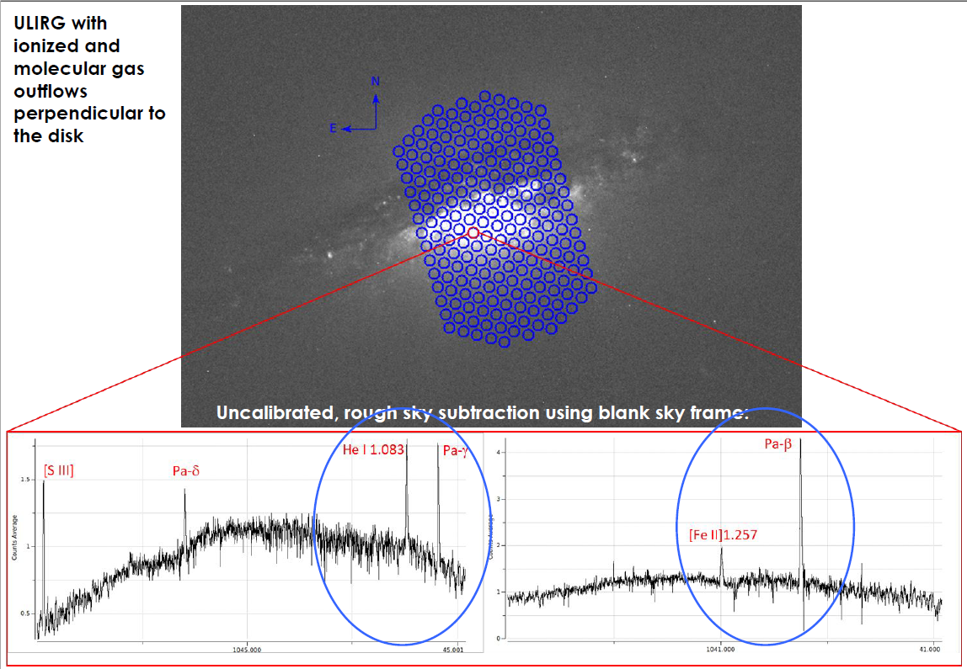
Figure 13: NIRWALS IFU footprint overlayed over a ULIRG that was observed during commissioning. Bottom: examples of spectra from one of the fibers taken at different grating settings. These are from uncalibrated data that only underwent sky subtraction by subtracting an observation of the sky from the target.

First light on 7 July, images below:

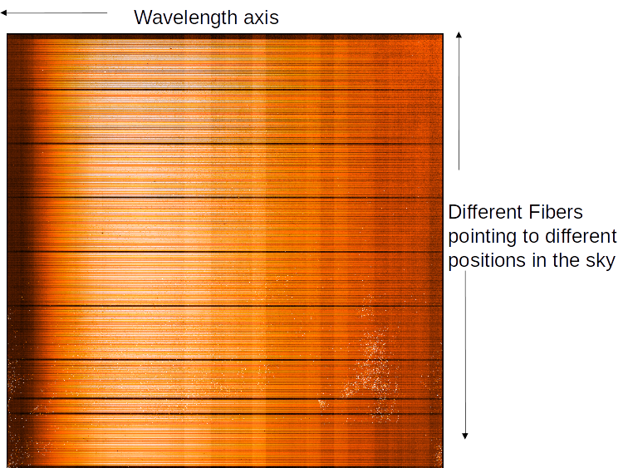

Figure14: Uncalibrated NIR data for a QTH2 exposure one. Each horizontal stripe is light coming from an individual fiber.

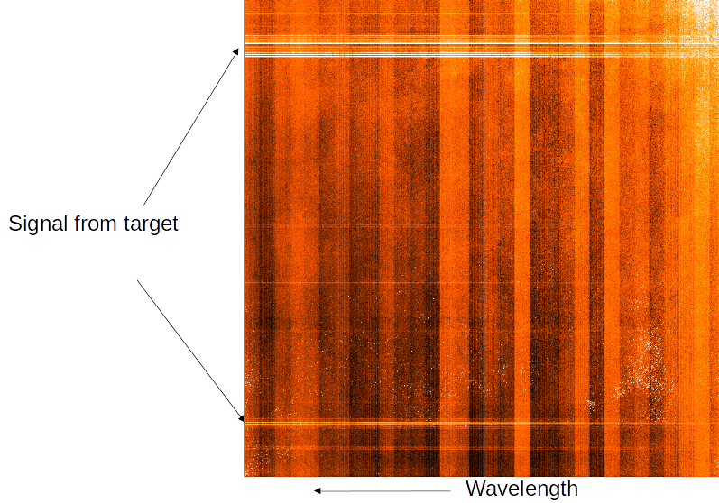

Figure 15: Unreduced and uncalibrated first light data of the bluest grating setting. This is from a 4s exposure of a de-focused bright star: HD189140, (M0II/III, V~6.1 mag, J~3 mag). The bright traces are signal from the target.
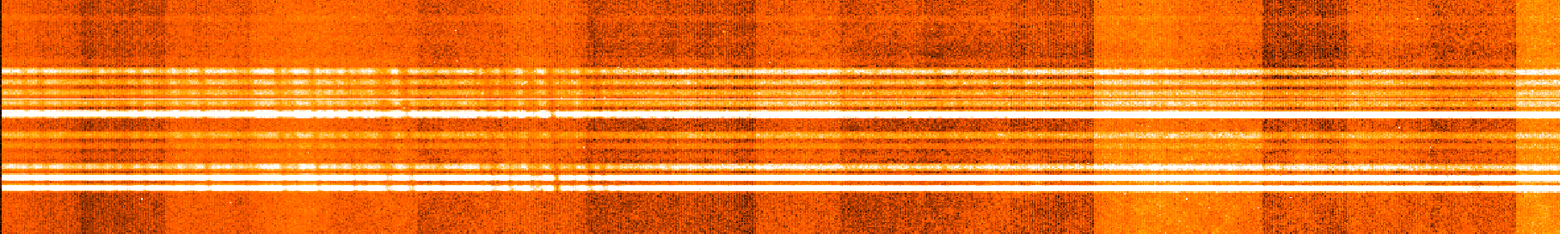

Figure 16: Zoomed image of a section of the uncalibrated data shown in Figure 14. This shows the traces from the target, with continuum and absorption lines visible.

